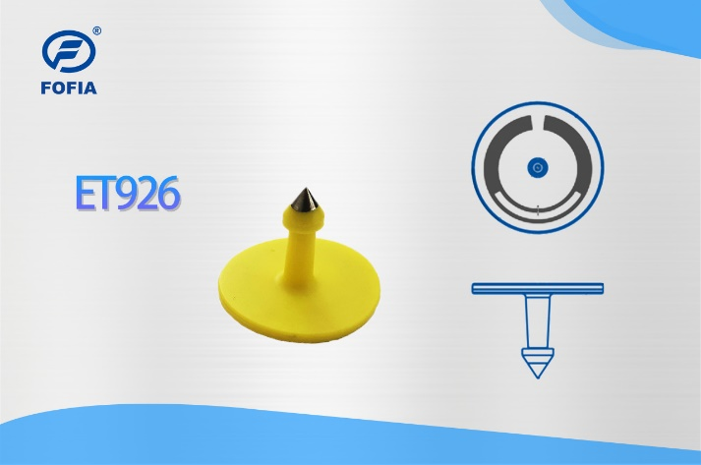无标题.png

This animal electronic ear tag is a kind of tag that designed exclusively for the animal breeding and slaughter management.

Each tag is produced using top quality European chips with read/write capability and features unique data security.

This product provides open-top-side and closed-top-side two designs. Adopting the over molding process, it is waterproof and anti-shedding. Coupled with Fofia Tech reader series, this ear tag provides a beneficial solution in animal breeding, slaughter management and animal identification.

Company Profile

Wuxi Fofia Technology Co., Ltd was founded in 2002. It’s a provincial high-tech enterprise in Jiangsu. We focus on the research, development, production and sales of the products in animal identification technology field.

Company Advantages

Wuxi Fofia Technology Co., Ltd is a leading supplier of animal identification products in Asian and Pacific area. We provide professional pet ID microchips, animal electronic ear tags, readers, handheld equipment and system integration. All our animal identification products are developed and produced based on 134.2 KHz ISO11784/85 FDX-B standards. We have been approved by the International Committee for Animal Recording (ICAR). We devote ourselves to providing RFID solutions to animal tracking, animal husbandry informatization and food safety & source-tracing management.

Strategic Cooperation

Wuxi Fofia Technology Co., Ltd will develop into a company that can provide complete solutions including IC card, equipment, application software and system integration. We’re committed to the development and promotion of animal identification technology. We’ll win customers’ trust with our high-quality products and first-class service. We warmly welcome the direct users of food safety source-tracing project implementation and system integrators to cooperate with us. We’ll try our best to provide the best solution of food safety & source-tracing for you.

[*www.fofia.com*](http://www.fofia.com)

Tel: 86-0510-85282218-8009

Email: [lisa.qiu@fofia.com](mailto:lisa.qiu@fofia.com)

Mob: 15949235501

|  |  |
| --- | --- |
| **Chip Specification** | |
| **standard** | EPC Gen2 v2.0 |
| **frequency** | 860-960MHz |
| **Work mode** | R/W |
| **Ear Tag Specification** | |
| **Write range** | 0～3m（与读写器和环境相关） |
| **Read range** | 0～3m（与读写器和环境相关） |
| **EPC memory** | up to 128 bits |
| **Diameter** | Ø31.8±0.2mm |
| **Height** | 23.5±0.3mm |
| **Mass** | 3g |
| **TID size** | 96 bits |
| **Access password** | 32 bits |
| **Kill password** | 32 bits |
| **Write cycle** | Minimum 100,000 |
| **Others** | |
| **Anticollision** | Multi-tag anti-collision read support |
| **Polarization** | Linear Polarized |

Sales Hotline

**ET906+T926 Animal Electronic Ear Tag**

无锡市富华科技有限责任公司

WUXI FOFIA TECHNOLOGY CO.,LTD.