无锡市富华科技有限责任公司

WUXI FOFIA TECHNOLOGY CO.,LTD.

# Company Profile

Wuxi Fofia Technology Co., Ltd was founded in 2002. It’s a provincial high-tech enterprise in Jiangsu. We focus on the research, development, production and sales of the products in animal identification technology field.

# Company Advantages

Wuxi Fofia Technology Co., Ltd is a leading supplier of animal identification products in Asian and Pacific area. We provide professional pet ID microchips, animal electronic ear tags, readers, handheld equipment and system integration. All our animal identification products are developed and produced based on 134.2 KHz ISO11784/85

FDX-B standards. We have been approved by the International Committee for Animal Recording (ICAR). We devote ourselves to providing RFID solutions to animal tracking, animal husbandry informatization and food safety & source-tracing management.

# Strategic Cooperation

Wuxi Fofia Technology Co., Ltd will develop into a company that can provide complete solutions including IC card, equipment, application software and system integration. We’re committed to the development and promotion of animal identification technology. We’ll win customers’ trust with our high-quality products and first- class service. We warmly welcome the direct users of food safety source-tracing project implementation and system integrators to cooperate with us. We’ll try our best to provide the best solution of food safety & source-tracing for you.

**PT289 UHF Stick Reader**

## PT289 UHF stick reader is an electronic tag reader that produced by Fofia Tech in 2021, meeting the need of domestic and international livestock management informatization. It’s domestically initiated and reaches the international advanced level.

Its unique design of stick antenna meets the actual demand. The shell is durable and reliable due to its high-strength material. It has large data storage and supports both USB and bluetooth data transmission. It can read all types of electronic tags that complied with the international animal identification standard.

PT289 UHF stick reader is conveniently used in breeding stock and dairy stock management, fat stock breeding, slaughter and so on. In animal identification, the reader can recognize the tag number automatically without contact or human intervention. It can ensure tag number’s unique and counterfeit proof features with its mature, stable and unique design.

[*www.fofia.com*](http://www.fofia.com/)

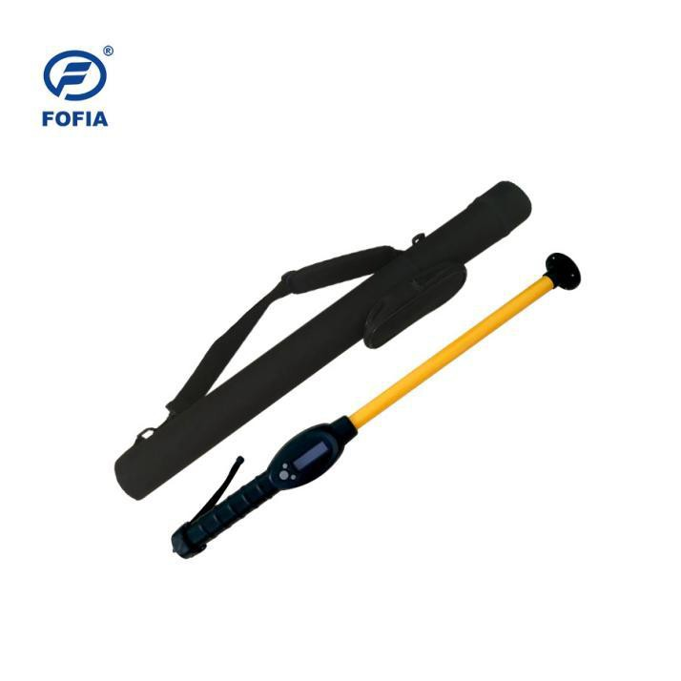

|  |  |  |  |  |  |
| --- | --- | --- | --- | --- | --- |
| **Main Parameter** | | **Working Manner** | | **Product Standard** | |
| **CPU** | ARM(STM32) | **Power Supply** | Lithium battery | **Color** | yellow black |
| **Working Frequency** | 840 ～  960MHz | **Communication Mode** | Bluetooth 3.0&  5.0 and USB | **Package size** | 79*10*10cm |
| **Screen** | 128*32  OLED | **Communication Port** | USB Type C | **G.W.** | 1500g |
| **Continuous Working**  **Time** | 12 hours | **Storage Temperature** | -30°C-65°C | **N.W.** | 540g |
| **Buzzer** | built-in | **Operation Temperature** | -30°C-50°C | **Button Number** | 3 |
| **Data Storage** | 14000  records | **Operation Humidity** | 5%～90% | **Indicator**  **Light** | no |
| **Others** | | | | | |
| **Reading Standard** | ISO18000-6C | | | | |
| **Operation Language** | simplified Chinese, traditional Chinese, English, Kazakh, Russian, Mongol, French, German, Spanish, Portuguese, Dutch, Danish, Italian | | | | |
| **Guarantee** | one year | | | | |
| **Accessories** | packing stick barrel, USB connecting cable | | | | |
| **Reading Distance** | Ear tag: more than 20cm | | | | |

Sales Hotline

## Tel: 86-0510-85282218-8009

Email： [lisa.qiu@fofia.com](mailto:lisa.qiu@fofia.com) Mob: 15949235501