
无锡市富华科技有限责任公司
WUXI FOFIA TECHNOLOGY CO.,LTD.

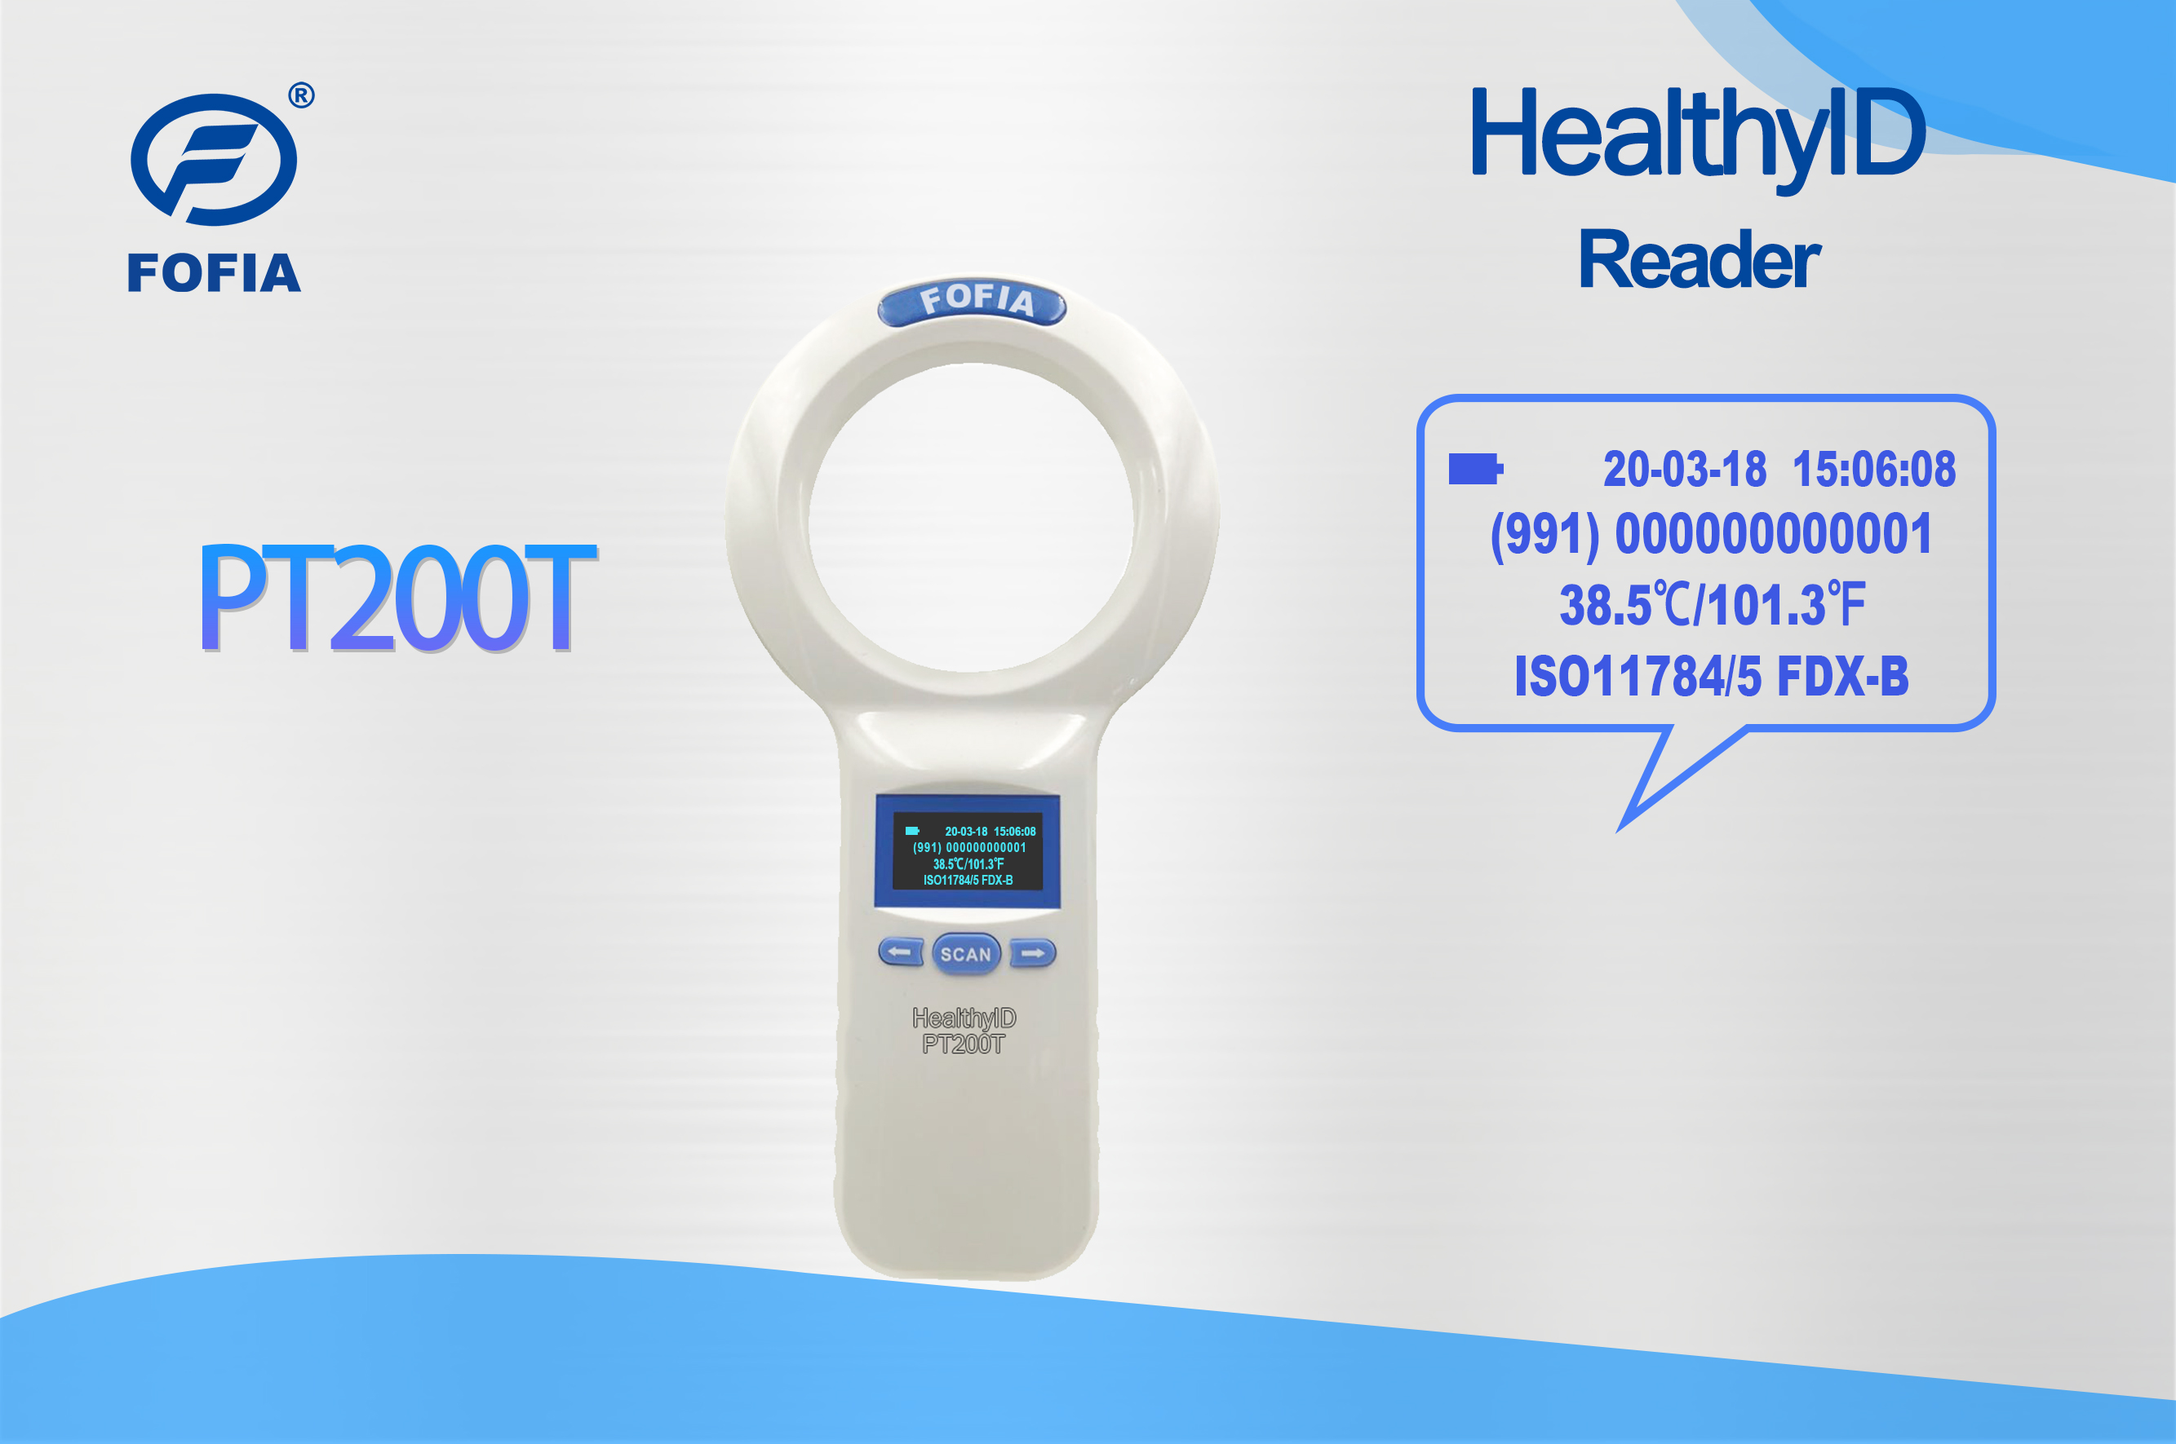

PT200T is a handheld reader that developed by Fofia Tech, catering to the application market of pet ID and animal identification.
- Reads all 134.2kHz ISO11784/5 microchips
- Read the temperature in FOFIA HT001 chip
- USB cable to transfer information to PC
- 1000 IDs in memory
- One year quality warranty
- TTF and RTF two operating modes
- Multiple operating languages

Sales Hotline
Tel: 86-0510-85282218-8009
Email： lisa.qiu@fofia.com
Mob: 15949235501

Main Parameter |  | Working Manner |  | Product Standard
Memory | 1000 IDs | Power supply | 3 AA | Color | White
Working frequency | 134.2KHz | Communication | MicroUSB | Package | 30*16.8*3.8cm
Screen | 128*64 1.54’’OLED | Continuous working time | 12 hours | Size | 25*12.6*3.1cm
System clock | built-in | Storage temperature | -30°C-65°C | G.W. | 310g
Buzzer | built-in | Operation temperature | -30°C-50°C | N.W. | 160g
Others
Reading standard | ISO11784/5 FDX-B and FOFIA HealtyID Thermo chip
Certification | CE,ROHS
Guarantee | one year
Accessories | packing box, USB cable
Reading distance | Animal ID tag: 10cm / HealthyID tag: 5cm
Operation language | 14 language choices: Simplified Chinese, Traditional Chinese, English,Kazakh, Russian, Mongol, French, German, Spanish, Portuguese, Dutch, Danish,Polish,Italian

Company Profile

Wuxi Fofia Technology Co., Ltd was founded in 2002. It’s a national high-tech enterprise in Jiangsu. We focus on the research,development,production and sales of the products in animal identification technology
field.

Company Advantages

Wuxi Fofia Technology Co., Ltd is a leading supplier of animal identification products in Asian and Pacific area. We provide professional pet ID microchips, animal electronic ear tags, readers, handheld equipment and system integration. All our animal identification products are developed and produced based on 134.2 KHz ISO11784/85 FDX-B standards. We have been approved by the International Committee for Animal Recording (ICAR). We devote ourselves to providing RFID solutions to animal tracking, animal husbandry informatization and food safety & source-tracing management.

Strategic Cooperation

Wuxi Fofia Technology Co., Ltd will develop into a company that can provide complete solutions including IC card, equipment, application software and system integration. We’re committed to the development and promotion of animal identification technology. We’ll win customers’ trust with our high-quality products and first-class service. We warmly welcome the direct users of food safety source-tracing project implementation and system integrators to cooperate with us. We’ll try our best to provide the best solution of food safety & source-tracing for
you.

www.fofia.com

PT200T RFID and Temperature Reader

