

无标题.png 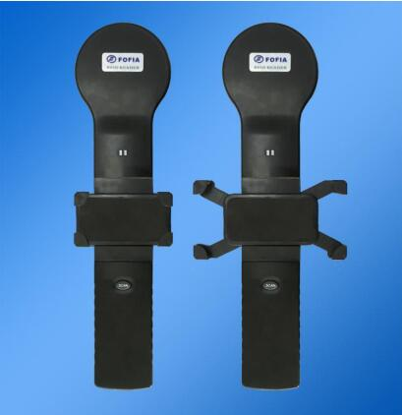

|  |  |  |  |
| --- | --- | --- | --- |
| **Main Parameter** | | **Working Manner** | |
| **CPU** | ARM(STM32) | **power supply** | lithium battery |
| **working frequency** | 134.2KHz | **communication mode** | Bluetooth BLE4.0 |
| **screen** | No screen, work with cellphone | **continuous working time** | 12 hours |
| **Color** | Black | **storage temperature** | -30°C-65°C |
| **buzzer** | built-in | **operation temperature** | -30°C-50°C |
| **data storage** | No | **Package size** | 48*20*8cm |
| **G.W.** | 740g | **N.W.** | 400g |
| **Others** | | | |
| **reading standard** | ISO11784/5 FDX-B ,HDX, ID64 | | |
| **operation language** | English, Chinese | | |
| **Guarantee** | one year | | |
| **accessories** | Manual book, USB connecting cable | | |
| **antenna** | lengths of antenna part: 10.5cm | | |
| **reading distance** | Ear tag: 17 cm  Microchip :9 cm | | |
| **certificate** | CE | | |

PT360 reader is used together  
with your smart phone (smaller than 95*185mm). The data will display directly on your phone when reading a tag. We can supply the APP or you can develop it based on our Free SDK.

It realizes the intelligent animal management.

PT360 support 134.2khz ISO11784/5 FDX-B / HDX

Tel: 86-0510-85282218-8010

Email： [jason@fofia.com](mailto:jason@fofia.com)

Mob: +86 13961822450

Sales Hotline

**PT360 Reader**

Company Profile

Wuxi Fofia Technology Co., Ltd was founded in 2002. It’s a provincial high-tech enterprise in Jiangsu. We focus on the research, development, production and sales of the products in animal identification technology field.

Company Advantages

Wuxi Fofia Technology Co., Ltd is a leading supplier of animal identification products in Asian and Pacific area. We provide professional pet ID microchips, animal electronic ear tags, readers, handheld equipment and system integration. All our animal identification products are developed and produced based on 134.2 KHz ISO11784/85 FDX-B standards. We have been approved by the International Committee for Animal Recording (ICAR). We devote ourselves to providing RFID solutions to animal tracking, animal husbandry informatization and food safety & source-tracing management.

Strategic Cooperation

Wuxi Fofia Technology Co., Ltd will develop into a company that can provide complete solutions including IC card, equipment, application software and system integration. We’re committed to the development and promotion of animal identification technology. We’ll win customers’ trust with our high-quality products and first-class service. We warmly welcome the direct users of food safety source-tracing project implementation and system integrators to cooperate with us. We’ll try our best to provide the best solution of food safety & source-tracing for you.

[*www.fofia.com*](http://www.fofia.com)

无锡市富华科技有限责任公司

WUXI FOFIA TECHNOLOGY CO.,LTD.