

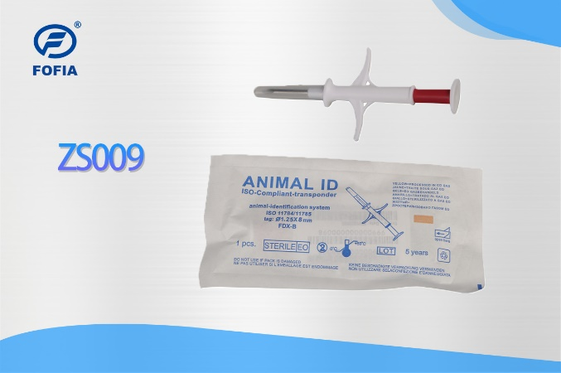无标题.png

Tel: 86-0510-85282218-8009

Email: [lisa.qiu@fofia.com](mailto:lisa.qiu@fofia.com)

Mob: 15949235501

Company Profile

Wuxi Fofia Technology Co., Ltd was founded in 2002. It’s a provincial high-tech enterprise in Jiangsu. We focus on the research, development, production and sales of the products in animal identification technology field.

Company Advantages

Wuxi Fofia Technology Co., Ltd is a leading supplier of animal identification products in Asian and Pacific area. We provide professional pet ID microchips, animal electronic ear tags, readers, handheld equipment and system integration. All our animal identification products are developed and produced based on 134.2 KHz ISO11784/85 FDX-B standards. We have been approved by the International Committee for Animal Recording (ICAR). We devote ourselves to providing RFID solutions to animal tracking, animal husbandry informatization and food safety & source-tracing management.

Strategic Cooperation

Wuxi Fofia Technology Co., Ltd will develop into a company that can provide complete solutions including IC card, equipment, application software and system integration. We’re committed to the development and promotion of animal identification technology. We’ll win customers’ trust with our high-quality products and first-class service. We warmly welcome the direct users of food safety source-tracing project implementation and system integrators to cooperate with us. We’ll try our best to provide the best solution of food safety & source-tracing for you.

[*www.fofia.com*](http://www.fofia.com)

Sales Hotline

|  |  |
| --- | --- |
| **Microchip Specification** | |
| **R/W standard** | ISO11784/5 FDX-B |
| **frequency** | 134.2KHz |
| **dimension** | Ø1.25*8mm |
| **anti-collision standard** | IP67 |
| **Guarantee** | 10years |
| **storage temperature** | -20°C to +50°C |
| **operation temperature** | 0°C to 50°C |
| **Transponder Syringe Specification** | |
| **color** | white |
| **weight** | 6.86g |
| **length** | 111±2mm |
| **width** | 50±1mm |
| **Others** | |
| **injection material** | PP |
| **packing manner** | 20 pcs/bag |
| **sterilization** | EO gas, 5 years’ guarantee |
| **Bar code label** | 6 adhesive-stickers |
| **International certification** | International Committee For Animal Recording (ICAR) |

**ZS009 is a kind of syringe that designed exclusively for animals. It contains a** disposable syringe, a parylene coating microchip, 6 one-dimensional bar code labels and a sterilized paper-plastic packing pouch.

This product meets all international standards of animal identification (ISO 11784/ISO 11785). Each syringe is produced using top quality European chips with read/write capability and features unique data security. Coupled with Fofia Tech reader series, ZS009 provides a beneficial solution in animal breeding, slaughter management and animal identification.

As we adopt the 1.25*8mm microchip electronic tag produced by the world’s leading technology, this syringe is light, handy and more humane to use.

**ZS009 Animal ID microchips**

无锡市富华科技有限责任公司

WUXI FOFIA TECHNOLOGY CO.,LTD.